# File permissions in Linux

## Project description

In the activity managing authorization lab, I used commands on Linux to check and modify file and directory permissions.

## Check file and directory details

To check for the file and directory details, first you must be on the directory that you want to check. On the root directory, you can put the command: *ls* to list all the directory. To access that directory, you can put the command: *cd* *directoryname.*  To view the permission and details of the directories and files, you can put the command: *ls -la.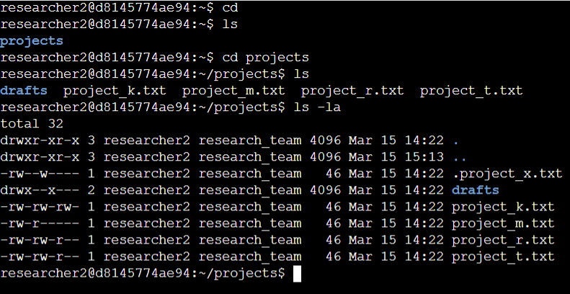*

## Describe the permissions string

The permission string is consisted of 10 strings, the first one represents, if it is a file or directory, the next three represents the permission of the owner, the next three represents the permissions of the group, and the last three strings represents the permissions of others.

## Change file permissions

To change permission of a file or directory, you can use the command *chmod*, followed by the value of each permssions (4 – read, 2 – write, 1 – execute, 0 – no permission). Example of it is *chmod 700*, which interprets as, for the owner, (4 – read, 2 – write, 1 - execute) permission, the group has no permission since it is 0, as well as other users since it is 0.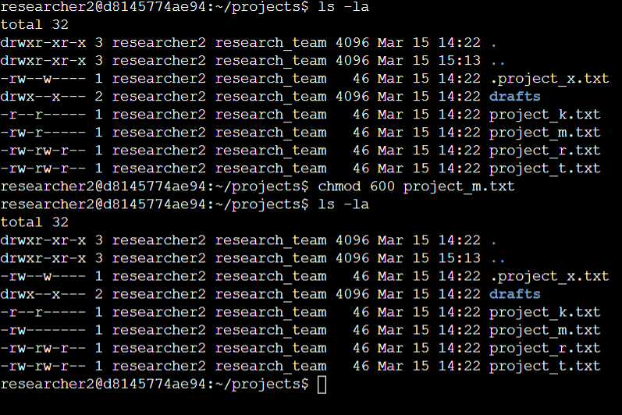

## Change file permissions on a hidden file

To change file permission on a hidden file, use again *chmod.* Example: *chmod 700 .project_x.txt*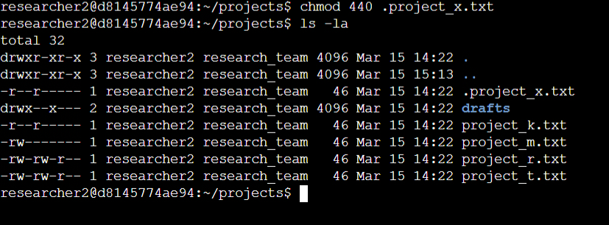

## Change directory permissions

To change file permission on a directory, use again *chmod.* Example: *chmod 700 drafts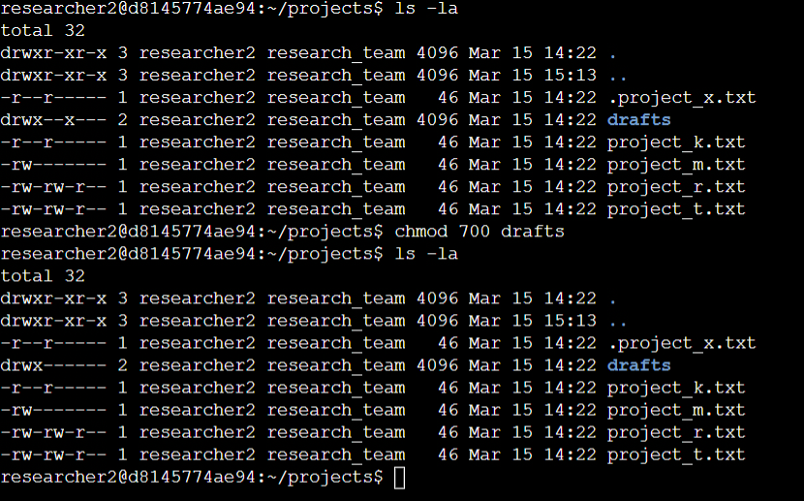*

## Summary

File permission management on Linux is important, you can manage access control, Prevent security threat attacks, file integrity, and user accountability. It helps manage your files securely and efficiently.